**HORMISDALLEN SCHOOL - KYEBANDO**

**PRE- PLE SET 2 EXAMINATIONS, 2023**

**PRIMARY SEVEN SOCIAL STUDIES**

**Duration: 2 Hours 15 Minutes**

**NAME: ______________________________________________ STREAM: _________**

INDEX NO.

EMIS NO.

**SECTION A**

1. State any one condition of weather where one needs to use an umbrella.

____________________________________________________________________

1. Apart from food and water, mention any one other need a person cannot live without.

____________________________________________________________________

1. In which one way can the government help farmers in rural areas to increase on agricultural produce?

____________________________________________________________________

1. Why do schools organize regular prefects’ elections?

____________________________________________________________________

1. Write SACCO in full.

____________________________________________________________________

1. Give one way in which missionaries contributed to the health of people of Uganda.

____________________________________________________________________

1. Why do people who live in desert areas usually build houses with flat roof?

____________________________________________________________________

1. How is lake Kyoga different from Lake Edward in their process of formation?

____________________________________________________________________

1. State any one service government provider that makes it easy for people to carry lout trade.

____________________________________________________________________

1. Give any one reason why there are many types of vegetation in Africa.

____________________________________________________________________

1. State any one way in which electricity is useful in industries.

____________________________________________________________________

1. Give a reason why Uganda imports purified oil yet it has a lot of crude in the Albertine Graben.

____________________________________________________________________

1. How are the Karimajong of Uganda and Fulani of Nigeria similar in their occupation?

____________________________________________________________________

1. State the major use of lines of latitude and longitude on a map.

____________________________________________________________________

1. Give a reason why there is need to protect elephants from poachers.

____________________________________________________________________

1. How do people benefit from swamps?

____________________________________________________________________

1. Why was it easier for the British to rule over Buganda and not Karamoja?

____________________________________________________________________

1. State any one reason why the government introduced Universal Primary Education(UPE)

____________________________________________________________________

1. Name the country in East Africa that was greatly affected by the first world war.

____________________________________________________________________

1. In which one way does the land resource contribute to the economic development of a country?

____________________________________________________________________

1. How is the East African community important to people in East Africa?

____________________________________________________________________

1. Why was the Truth and Reconciliation Commission established in South Africa after apartheid?

____________________________________________________________________

1. How did Assimilation policy weaken African societies to resist colonial rule?

____________________________________________________________________

1. How does a mixed farmer benefit from a mixed farm?

____________________________________________________________________

1. Why is child abuse on a high rate in the African countries?

____________________________________________________________________

1. Mention any one source of raw materials used for making crafts.

____________________________________________________________________

1. How does a civil war in a country lead to the abuse of human rights?

____________________________________________________________________

1. State any one effect of spending money without a budget.

____________________________________________________________________

1. How did the Trans Atlantic trade affect the continent of Africa?

____________________________________________________________________

1. Why is it advisable for poorer countries to join international organisations like UN and Commonwealth?

____________________________________________________________________

1. Why doesn’t Uganda have a national language?

____________________________________________________________________

1. Mention one way rural electrification programme promotes environmental protection?

____________________________________________________________________

1. Name the largest irrigation scheme famous for cotton growing in Sudan.

____________________________________________________________________

1. Why do Equatorial climate zones receive convectional rainfall?

____________________________________________________________________

1. What advantage does a home get from being located near a market center?

____________________________________________________________________

**For each of the questions 36 to 40, answer EITHER Christianity OR Islam but not both.**

1. **Either:** a) Who is regarded as a prince of peace in Christianity?

____________________________________________________________________

**OR:** a) Who is referred to as Al-min?

___________________________________________________________________

1. **Either:** a) Mention any one way Christians ask for their needs from God.

____________________________________________________________________

**OR:** a) Mention any one way Muslims ask for their needs from Allah.

___________________________________________________________________

1. **Either:** a) How did Moses show disrespect to God during the Exodus?

____________________________________________________________________

**OR:** a) How did Musa show disrespect to God during the Exodus?

___________________________________________________________________

1. **Either:** a) Mention any one way Christians should prepare for the Day of Judgment.

____________________________________________________________________

**OR:** a) Mention any one way Muslims should prepare for the Day of Judgment.

___________________________________________________________________

1. **Either:** a) As a child of God, why is there need to forgive one another?

____________________________________________________________________

**OR:** a) As a child of Allah, why is there need to forgive one another?

____________________________________________________________________

**SECTION B(6oMARKS)**

1. a) What is excise tax?

___________________________________________________________________

b) Mention the authority body that collects and assesses taxes in Uganda.

___________________________________________________________________

c) Mention two ways the government uses the taxes collected from business and people.

i)__________________________________________________________________

ii)__________________________________________________________________

1. Study the diagram below showing the population distribution in a few selected areas of Uganda and use it to answer the questions that follow.

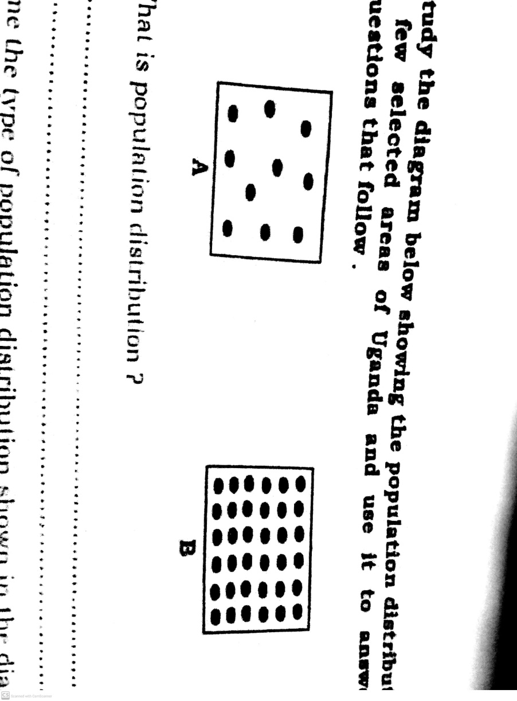

a) What is population distribution?

___________________________________________________________________

b) Name the type of population distribution shown in the diagram.

i)A_________________________________________________________________

ii)B________________________________________________________________

c) Give any one danger of population distribution labeled B.

___________________________________________________________________

1. a) What is meant by the term scramble for Africa?

___________________________________________________________________

b) Name any two European powers which scrambled for East Africa.

i)__________________________________________________________________

ii)__________________________________________________________________

c) How did the scramble for Africa affect Africans negatively?

___________________________________________________________________

1. a) Give any one role of each of the following arms of government.
2. Legislature________________________________________________________
3. Judiciary__________________________________________________________

b) In which one way does the executive promote law and order in the country?

___________________________________________________________________

c) Under which ministry are all the districts in Uganda?

___________________________________________________________________

1. Study the diagram below and answer the questions that follow.

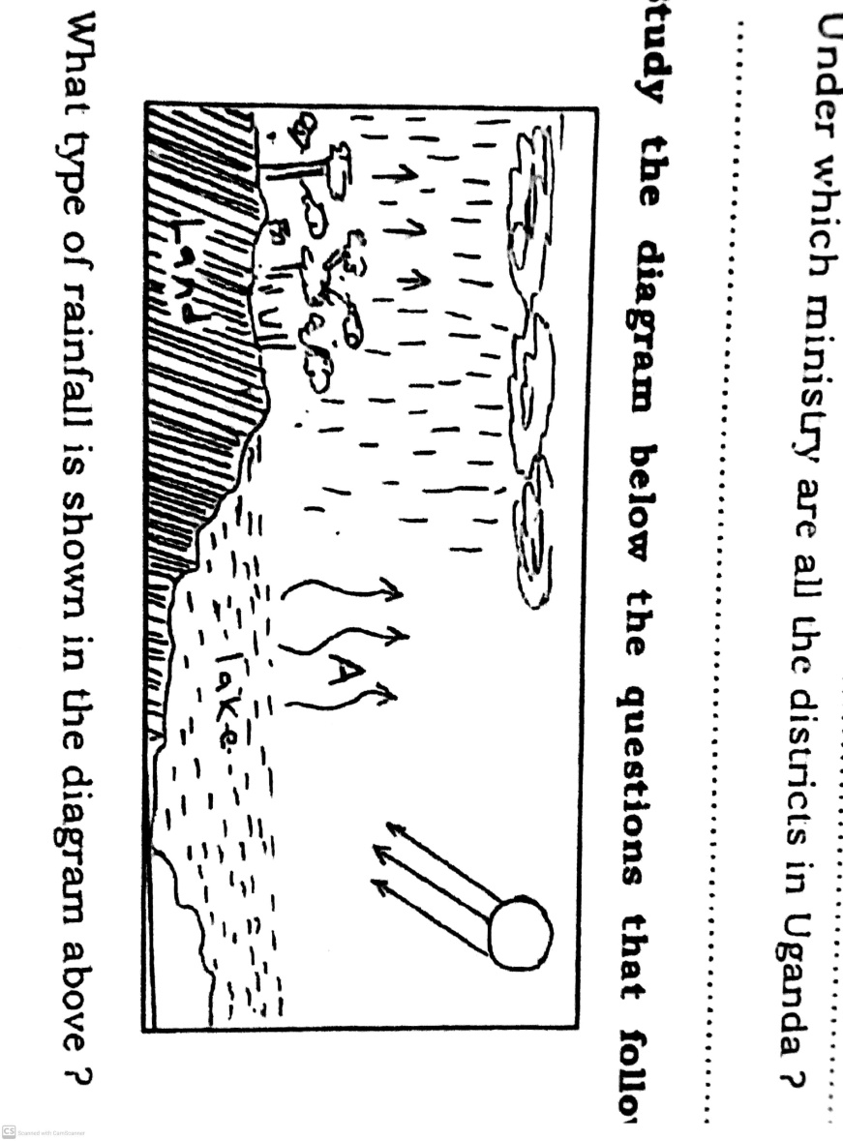

a) What type of rainfall is shown in the diagram above?

___________________________________________________________________

b) Name the process at A.

___________________________________________________________________c) Name any one region of Uganda which does not receive the above type of rainfall.

___________________________________________________________________

d) In which one way can people preserve the climate of an area?

___________________________________________________________________

1. a) What are economic resources?

___________________________________________________________________

b) Give any one example of an economic resource.

___________________________________________________________________

c) State any two reasons why Africa has failed to fully utilize her resources.

i)_________________________________________________________________

ii)_________________________________________________________________

1. a) What are by-elections?

___________________________________________________________________

b) Give any two causes of by-elections in Uganda?

i)_________________________________________________________________

ii)_________________________________________________________________

c) State any one effect of election malpractice in a country.

___________________________________________________________________

1. a) Who is a leader?

___________________________________________________________________

b) Give any two ways of getting leaders in our district.

i)__________________________________________________________________

ii)__________________________________________________________________c) What title is given to the district official in charge of children’s affairs?

___________________________________________________________________

1. Study the map of Africa and use it to answer the questions that follow.

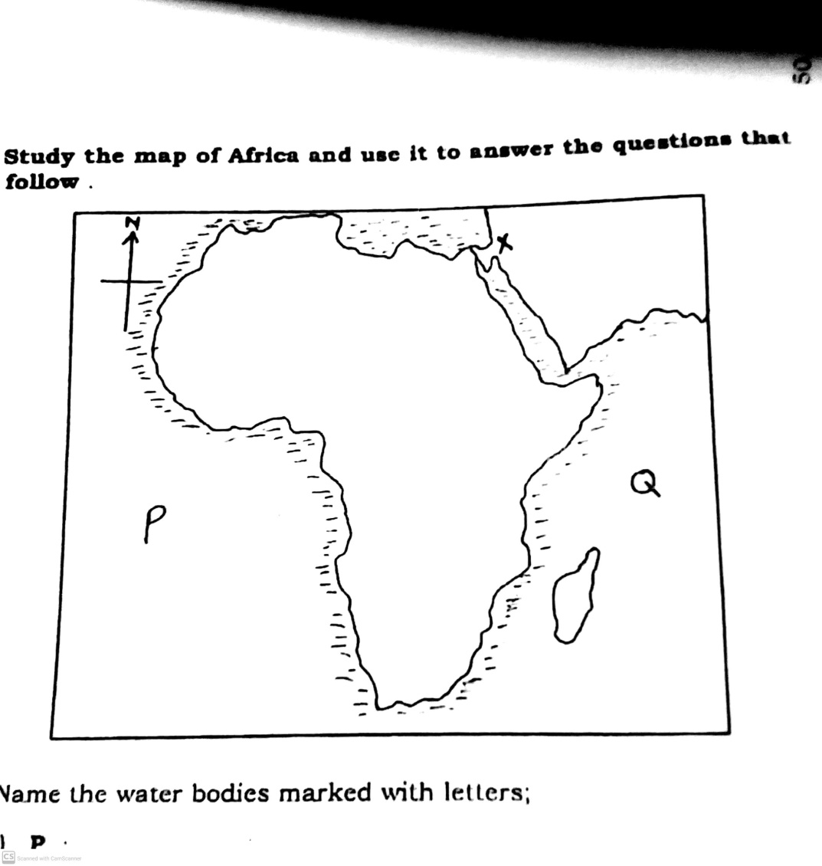

a) Name the water bodies marked with letter;

i) P________________________________________________________________

ii) Q________________________________________________________________

b) Give any one reason why canal marked with letter X was constructed.

__________________________________________________________________

**c) Use letter B to show the largest continent in the world.**

1. Match the list of items in A to B correctly.
2. The 1900 Buganda Agreement led to the final partition of East Africa
3. The 1901 Ankole Agreement led to the final partition of East Africa
4. The Heligo land Treaty led to the final partition of East Africa
5. The Namirembe Agreement led to the final partition of East Africa
6. The 1900 Buganda Agreement________________________________________
7. The 1901 Ankole Agreement__________________________________________
8. The Heligo land Treaty_______________________________________________
9. The Namirembe Agreement __________________________________________

**For each of the questions 51 to 55, answer EITHER Christianity OR Islam but not both in a number. No marks will be awarded to a candidate who attempts both alternatives in the same number.**

1. **Either:** a) Name the place in Egypt where the Israelites lived while in slavery.

___________________________________________________________________

b) Why did God send Moses to rescue the Israelites in Egypt?

___________________________________________________________________

c) Give any two ways in which the Israelites suffered while in slavery.

i)__________________________________________________________________

ii)__________________________________________________________________

**OR:** a) Name the place in Egypt where the Ban-Israel lived while in slavery.

___________________________________________________________________

b) Why did Allah send Prophet Musa to rescue the Ban-Israel in Egypt?

___________________________________________________________________

c) Give any two ways in which the Ban-Israel suffered while in slavery.

i)__________________________________________________________________

ii)__________________________________________________________________

1. **Either:** a) Which type of Authority is possessed by Satan and those under his control?

___________________________________________________________________

b) Give any one value of faith in Authority.

___________________________________________________________________

c) Mention any two ways in which Christians can misuse authority.

i)__________________________________________________________________

ii)__________________________________________________________________

**OR:** a) Which type of authority is possessed by Satan and those under his control?

___________________________________________________________________

b) Give any one value of faith in Authority.

___________________________________________________________________

c) Mention any two ways in which Muslims can misuse authority.

i)__________________________________________________________________

ii)__________________________________________________________________

1. **Either:** Match items in list A to those in list B correctly.

|  |  |
| --- | --- |
| **List A** | **List B** |
| Isaiah | preached about repentance |
| Jeremiah | preached about the coming of the messiah |
| Jonah | reminded the Israelites of God’s love |
| Jeremiah | Preached about judgment on Nineveh |

**OR:** Match items in list A to those in list B correctly.

|  |  |
| --- | --- |
| **List A** | **List B** |
| Ibrahim | first prophet in Islam |
| Adam | sent to guide the Ban-Israel |
| Alyasa | last prophet in Islam |
| Muhammad | Had a strong faith in Allah |

1. Ibrahim__________________________________________________________
2. Adam ___________________________________________________________
3. Alyasa___________________________________________________________
4. Muhammad_______________________________________________________
5. **Either:** a) Give any two act of charity you as a Christian child can do to help people in your community.

i)__________________________________________________________________

ii)__________________________________________________________________

b) Mention any two benefits Christians get from performing cats of charity.

i)__________________________________________________________________

ii)__________________________________________________________________

**OR:** a) Give any two act of charity you as a Muslim child can do to help people in your community.

i)__________________________________________________________________

ii)__________________________________________________________________

b) Mention any two benefits Muslims get from performing acts of charity.

i)__________________________________________________________________

ii)__________________________________________________________________

1. **Either:** a) Mention any one cause of death according to Christianity.

___________________________________________________________________

b) Give any two reasons why some Christians fear death.

i)__________________________________________________________________

ii)__________________________________________________________________

c) What should Christians do in order to avoid hell when they die?

___________________________________________________________________

**OR:** a) Mention any one cause of death according to islam.

___________________________________________________________________

b) Give any two reasons why some Muslims fear death.

i)__________________________________________________________________

ii)__________________________________________________________________

c) What should Muslims do in order to avoid Jahannam when they die?

___________________________________________________________________

**END**